***High-Level Design (LLD) Documentation***

**Foreign Direct Investment Data Analysis**



**Revision Number - 1.2**

**Last Date of Revision - 01/05/2024**

**RISHI KALPA MUKHERJEE**

**Document Control**

|  |  |  |  |
| --- | --- | --- | --- |
| **Date** | **Version** | **Description** | **Author** |
| 15/03/2024 | 1.0 | Abstract, Introduction, General Description | Rishi Kalpa Mukherjee |
| 23/04/2024 | 1.1 | Design Details, KPIs, Deployment | Rishi Kalpa Mukherjee |
| 01/05/2024 | 1.2 | Final Revision | Rishi Kalpa Mukherjee |

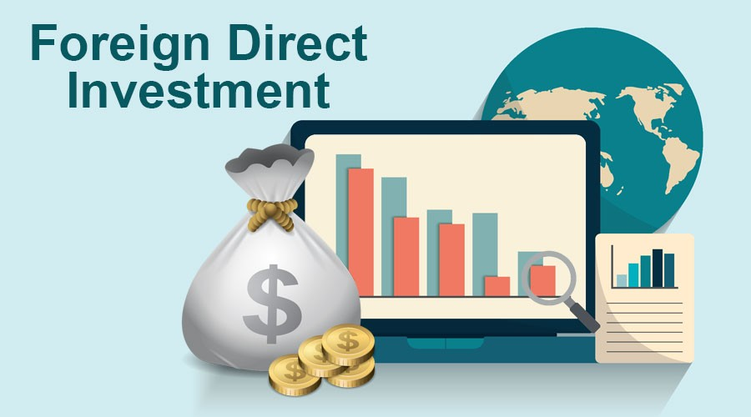

**CONTENTS**

**Document Version Control......................................................**

**Abstract……………………….........................................................4**

1. **Introduction………………………………………………………………………………….5**
   1. What is High-Level Design Document…………………………………………………….5
   2. Scope………………………………………………………………………………………………………5
2. **General Description…………………………………………………………………….5**
   1. Product Perspective & Problem Statement...................................5
   2. Tools Used .........................................................................6
3. **Design Detail..............................................................6** 
   1. Functional Architecture…….....................................................6
   2. Optimization .....................................................................8
4. **KPI ..........................................................................9** 
   1. KPIs (Key Performance Indicators) ............................................9
5. **Deployment...............................................................9**



**Abstract**

In today's globalized economy, foreign direct investment (FDI) and international funds have become increasingly important for businesses and investors alike. FDI refers to the investment made by a company or individual from one country into another country, while international funds are investment vehicles that invest in a diverse range of assets in multiple countries. These two concepts are closely linked, as international funds often invest in companies through FDI. Understanding the relationship between FDI and international funds is essential for investors looking to diversify their portfolio and companies seeking to expand their global presence.

Foreign Direct Investment (FDI) is considered as an engine of economic growth. Before the economic reforms, the flow of foreign direct investment to India has been comparatively limited because of the type of industrial development strategy and the various foreign investment policy followed by India. Government policy towards. Foreign capital was very selective. Foreign investment was normally permitted only in high technology industries in priority areas and export-oriented areas. So, the inflow of FDI before the 1990s was very low. To fully utilize the country’s immense economic potential, the government launched economic reform in 1991. The new government policies are simple, transparent. And promote domestic and foreign investment. India’s abundant and diversified natural resources, its sound economic policy, good market condition and high skilled human resources make it a proper generation for FDI. After long years of journey, FDI was also introduced in various sectors and states in India. The investment of FDI in various States and sectors leads to the rapid growth of the Indian economy.

The term foreign direct investment (FDI) refers to an ownership stake in a foreign company or project made by an investor, company, or government from another country. FDI is generally used to describe a business decision to acquire a substantial stake in a foreign business or to buy it outright to expand operations to a new region. The term is usually not used to describe a stock investment in a foreign company alone. FDI is a key element in international economic integration because it creates stable and long-lasting links between economies.

1. **Introduction** 
   1. **What is High-Level Design Document?**

The purpose of this High-Level Design (HLD) document is to add the necessary detail to the current project description to represent a suitable model for coding. This document is also intended to help detect contradictions before coding and can be used as a reference manual for how the modules interact at a high level.

The High-Level Document will:

• Present all of the design aspects and define them in detail

• Describe the user interface being implemented

• Describe the hardware and software interfaces

• Describe the performance requirements

• Include design features and the architecture of the project

• List and describe the non-functional attributes like:

-Security

-Reliability

-Maintainability

-Reusability

-Application compatibility

-Resource utilization

-Serviceability

* 1. **What is Scope?**

The HLD documentation presents the structure of the system, such as the database architecture, application architecture (layers), application flow (Navigation), and technology architecture. The HLD uses non-technical to mildly-technical terms which should be understandable to the administrators of the system.

1. **General Description** 
   1. **Product Perspective & Problem Statement**

This project aims to analyse Foreign Direct Investment in India from FY 2000-01 to FY 2016-17. The main aim is to get the meaningful details and information regarding Sector-wise and Year-wise Investment analysis Inflow.

* 1. **Tools used**

Python libraries like NumPy, Pandas, Seaborn and Matplotlib has been used. The dataset was in MS Excel and the data has been manipulated for getting the structured data. Business Intelligence tools like Tableau has been used for intuitive data visualizations and creating dashboard for end users.

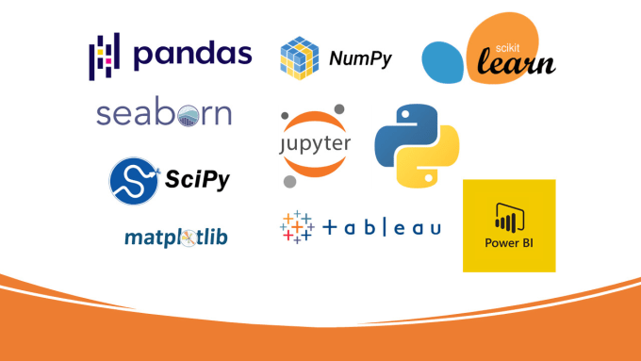

1. **Design Details**

**3.1 Functional Architecture**

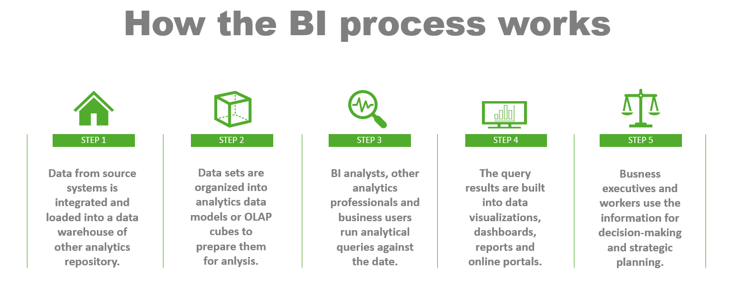

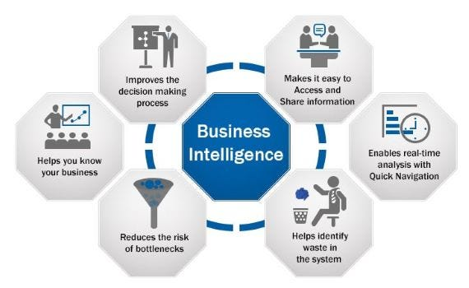

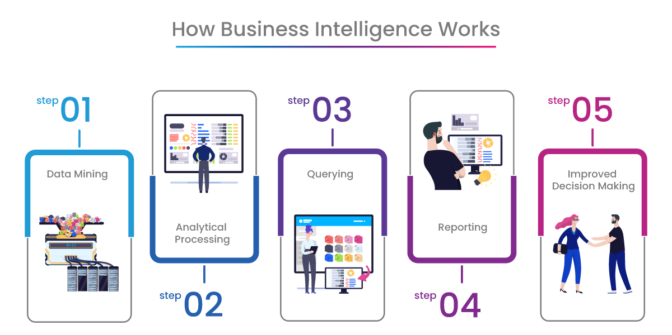

**Key takeaways:**

* *Business intelligence (BI) is an umbrella term that refers to a set of technologies and techniques used to extract data from various sources, analyse it, and present it to managers.*
* *BI can help you make better decisions by providing information about your business that’s relevant and accurate.*
* *BI can help you understand how different aspects of your business impact each other, so you can focus on what matters most and avoid distractions.*

Business Intelligence (BI) is a branch of information technology that uses data to help organisations make better business decisions. It can be used in various ways to improve your company’s performance.

**3.2 Optimization**

**1. Your data strategy drives performance**

* Minimize the number of fields.
* Minimize the number of records.
* Optimize extracts to speed up future queries by materializing calculations, removing columns and the use of accelerated views.

**2. Reduce the marks (data points) in your view**

* Practice guided analytics. There’s no need to fit everything you plan to show in a single view. Compile related views and connect them with action filters to travel from overview to highly-granular views at the speed of thought.
* Remove unneeded dimensions from the detail shelf.
* Explore. Try displaying your data in different types of views.

**3. Limit your filters by number and type**

* Reduce the number of filters in use. Excessive filters on a view will create a more complex query, which takes longer to return results. Double-check your filters and remove any that aren’t necessary.
* Use an include filter. Exclude filters load the entire domain of a dimension while including filters do not. An include filter runs much faster than an exclude filter, especially for dimensions with many members.
* Use a continuous date filter. Continuous date filters (relative and range-of-date filters) can take advantage of the indexing properties in your database and are faster than discrete data filters.
* Use Boolean or numeric filters. Computers process integers and Booleans (t/f) much faster than strings.
* Use parameters and action filters. These reduce the query load (and work across data sources).

1. **Optimize and materialize your calculations**

* Perform calculations in the database.
* Reduce the number of nested calculations.
* Reduce the granularity of LOD or table calculations in the view.

**4 KPI**

Key performance indicators (KPIs) are quantifiable measurements used to gauge a company’s overall long-term performance. KPIs specifically help determine a company’s strategic, financial, and operational achievements, especially compared to those of other businesses within the same sector.

**KEY TAKEAWAYS:**

Key performance indicators (KPIs) measure a company’s success vs. a set of targets, objectives, or industry peers.

KPIs can be financial, including net profit (or the bottom line, net income), revenues minus certain expenses, or the current ratio (liquidity and cash availability).

Customer-focused KPIs generally centre on per-customer efficiency, customer satisfaction, and customer retention.

Process-focused KPIs aim to measure and monitor operational performance across the organization.

Businesses generally measure and track KPIs through analytics software and reporting tools.

**4.1 KPIs (Key Performance Indicators)**

Key indicators displaying a summary of the FDI and its relationship with Sector-wise and Year-wise Investment

1. How much FDI each sector received from FY 2000-01 to FY 2016-17

2. Total FDI FY India FDI.

3. Top 10 Sectors.

4. Bottom 10 Sectors.

5. Forecast.

**5 Deployment**



Prioritizing data and analytics couldn’t come at a better time. Your company, no matter what size, is already collecting data and most likely Analysing just a portion of it to solve business problems, gain competitive advantages, and drive enterprise transformation. With the explosive growth of enterprise data, database technologies, and the high demand for analytical skills, today’s most effective IT organizations have shifted their focus to enabling self-service by deploying and operating latest Business Intelligence tool TABLEAU as well as organizing, orchestrating, and unifying disparate sources of data for business users and experts alike to author and consume content.

**DASHBOARD DIAGRAMS**

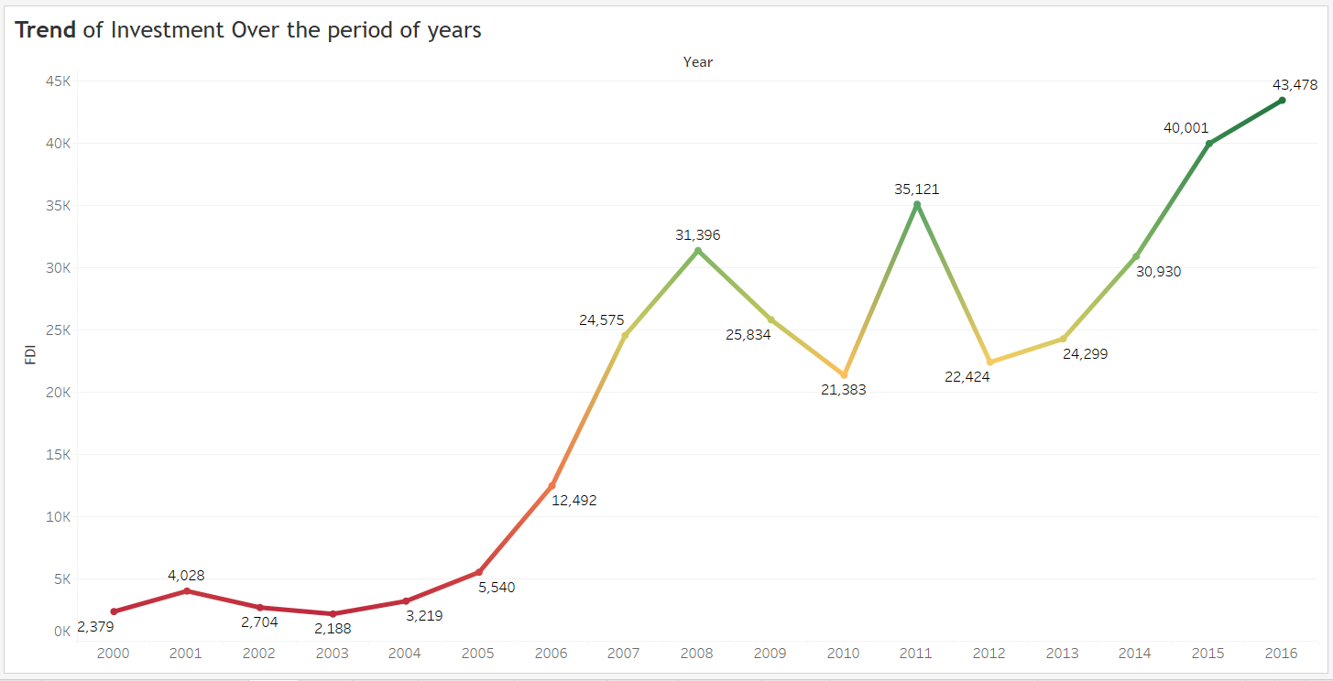

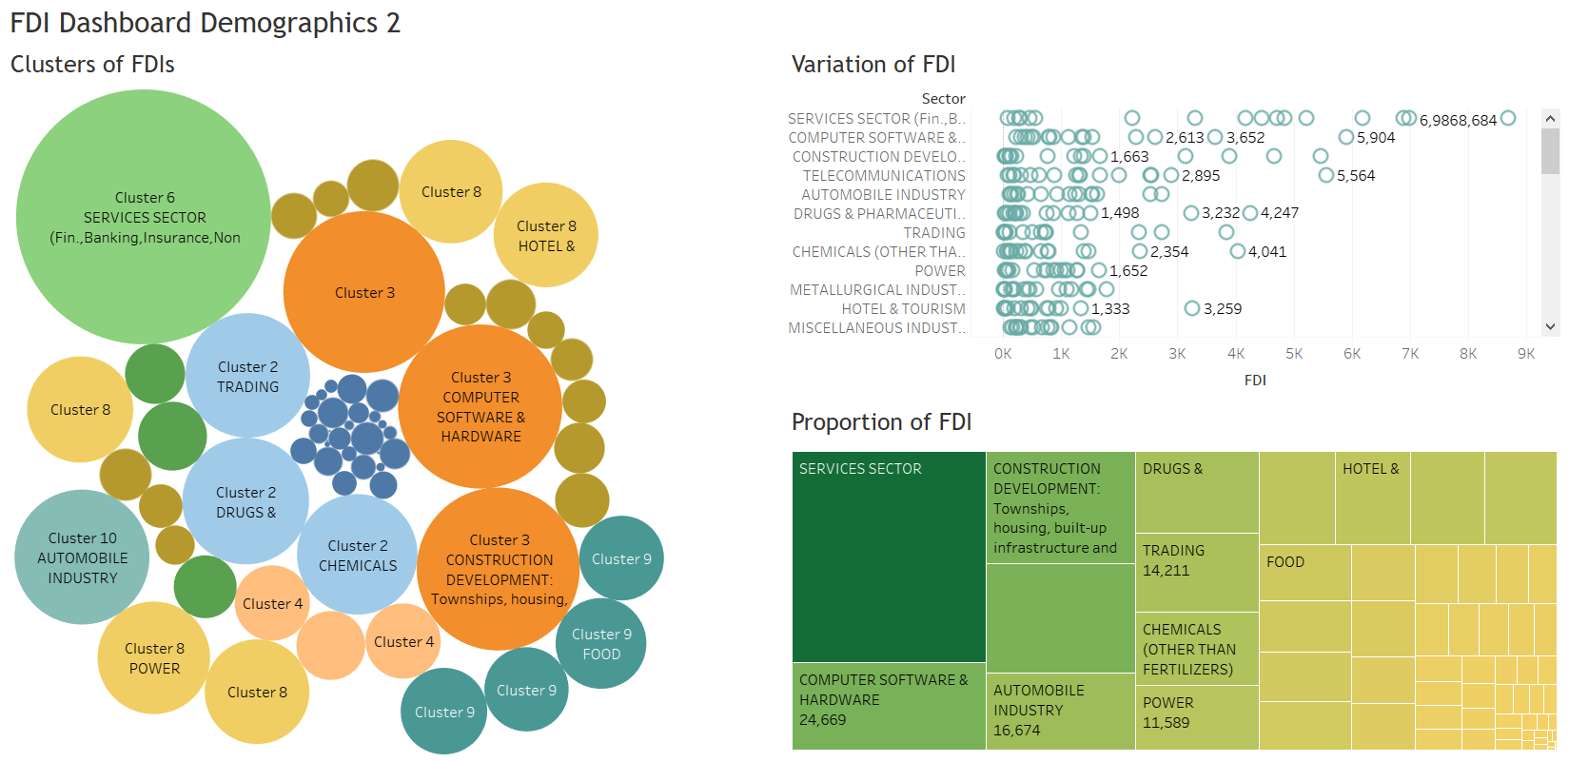

***End of High-Level Design Documentation***

FDI Data Analysis